A PROJECT REPORT

on

NEWS CLASSIFICATION USING BERT

Submitted to

KIIT Deemed to be University

In Partial Fulfilment of the Requirement for the Award of

BACHELOR’S DEGREE IN

INFORMATION TECHNOLOGY

BY

Akshat Banerjee
Surya Prasad Sahoo
Swastik Padhy

21051963
21052884
21052885

UNDER THE GUIDANCE OF

Abinas Panda


SCHOOL OF COMPUTER ENGINEERING

KALINGA INSTITUTE OF INDUSTRIAL TECHNOLOGY

BHUBANESWAR, ODISHA - 751024

March 2024

KIIT Deemed to be University

School of Computer Engineering
Bhubaneswar, ODISHA 751024

CERTIFICATE

This is certify that the project entitled

NEWS CLASSIFICATION USING BERT

submitted by

Akshat Banerjee
Surya Prasad Sahoo
Swastik Padhy

21051963
21052884
21052885

is a record of bonafide work carried out by them, in the partial fulfilment of the requirement for the award of Degree of Bachelor of Engineering (Computer Sci-ence & Engineering OR Information Technology) at KIIT Deemed to be university, Bhubaneswar. This work is done during year 2022-2023, under our guidance.

Date: 30 / 03/ 2024

Abinas Panda
Project Guide

Acknowledgements

We are profoundly grateful to Abinas Panda of KIIT SCSE for his expert guidance and continuous encouragement throughout to see that this project rights its target since its commencement to its completion. .....................

AKSHAT BANERJEE
SWASTIK PADHY
SURYA SAHOO

ABSTRACT

Your abstract, paragraph 1.

Your abstract, paragraph 2.

Keywords: Natural language processing, machine learning, transformers for news classification,data preprocessing, BERT transformer, Classification using machine learning

Contents

1 | Introduction |  |  | 1
2 | Basic Concepts/ Literature Review |  |  | 2
 | 2.1 | Sub Section Name........................... |  | 2
3 | Problem Statement / Requirement Specifications |  |  | 3
 | 3.1 | Project Planning........................... |  | 3
 | 3.2 | Project Analysis (SRS)................. |  | 3
 | 3.3 | System Design ………………….. |  | 3
 |  | 3.3.1 | Design Constraints …… | 3
 |  | 3.3.2 | System Architecture (UML) / Block Diagram … | 3
4 | Implementation |  |  | 4
 | 4.1 | Methodology / Proposal ........................... |  | 4
 | 4.2 | Testing / Verification Plan ……………. |  | 4
 | 4.3 | Result Analysis / Screenshots …………. |  | 4
 | 4.4 | Quality Assurance …………………….. |  | 4
5 | Standard Adopted |  |  | 5
 | 5.1 | Design Standards . . . . . . . . . . . . . . . |  | 5
 | 5.2 | Coding Standards . . . . . . . . . . . . . . |  | 5
 | 5.3 | Testing Standards . . . . . . . . . . . . . . . |  | 5
6 | Conclusion and Future Scope |  |  | 6
 | 6.1 | Conclusion ……………………….. |  | 6
 | 6.2 | Future Scope ………………………. |  | 6
References |  |  |  | 7
Individual Contribution |  |  |  | 8
Plagiarism Report |  |  |  | 9

List of Figures

1.1 | IMAGE CAPTION ......................... | 2
4.1 | IMAGE CAPTION ......................... | 9

Chapter 1

Introduction

The ever-growing volume of news creates a challenge: efficiently and precisely classifying articles into predefined categories. This is crucial for both news organizations managing content and readers seeking information relevant to their interests.
Traditional methods, like manual tagging or rule-based systems, struggle with the sheer volume and complexity of modern news. Deep learning, particularly transformers, offers a solution.
This paper explores the use of transformers, specifically the Bidirectional Encoder Representations from Transformers (BERT) model, for news classification. BERT's pre-training approach has revolutionized natural language processing (NLP) by achieving new benchmarks in tasks like this.
Unlike previous models, BERT utilizes a bidirectional approach, considering both preceding and following words to understand a word's context. This makes BERT adept at grasping the nuances of language, essential for accurate news classification.
Our research objective is to investigate the effectiveness of BERT in classifying news articles across various domains. By leveraging BERT's power, we aim to develop a robust and efficient system that adapts to the dynamic nature of news and reader interests.

Chapter 2

Basic Concepts/ Literature Review

(2.1) What is a Transformer :
In machine learning, a transformer refers to a type of model architecture that has gained significant popularity, especially in natural language processing (NLP) tasks. Transformers were introduced in the paper "Attention is All You Need" by Vaswani et al. in 2017.
A transformer model relies heavily on the mechanism of attention, which allows the model to focus on different parts of the input sequence when making predictions. Unlike previous sequence-to-sequence models that relied on recurrent neural networks (RNNs) or convolutional neural networks (CNNs), transformers do not use recurrence, making them more parallelizable and faster to train.
Key components of a transformer model include:
- Self-Attention Mechanism: This mechanism allows the model to weigh the importance of different words in the input sequence when predicting each word in the output sequence. Self-attention computes attention weights by comparing each word to every other word in the sequence.
- Multi-Head Attention: Transformers typically employ multiple attention heads in parallel, allowing the model to learn different representations of the input sequence. This helps capture different types of dependencies in the data.
- Positional Encoding: Since transformers do not inherently understand the sequential order of the input, positional encodings are added to the input embeddings to provide information about the position of each token in the sequence.
- Feedforward Neural Networks: Transformers also include feedforward neural networks, which are applied independently to each position in the sequence.
- Layer Normalization and Residual Connections: These techniques are commonly used to stabilize and speed up training in deep neural networks.
Transformers have achieved state-of-the-art performance in various NLP tasks such as language translation, text summarization, sentiment analysis, and more. They have also been adapted and extended to other domains beyond NLP, such as computer vision (e.g., Vision Transformer or ViT) and reinforcement learning.

(2.2) Understanding BERT:
BERT, developed by Google, is a powerful model in natural language processing that enhances contextual understanding of text through bi-directional representations.(BERT (language model), 2019)

BERT, short for Bidirectional Encoder Representations from Transformers, is a groundbreaking model in the field of natural language processing (Pahune & Manoj, 2023).
It has gained immense popularity due to its ability to capture the context of words and sentences effectively. By using a Transformer architecture, BERT can consider both the preceding and following words in a sentence, allowing it to comprehend the complete context. Furthermore, BERT is pre-trained on large amounts of data to learn the latent representations of words and sentences (Xiao & Zhu, 2023). This pre-training process enables BERT to understand the
relationships and meanings of words within the context they are used.

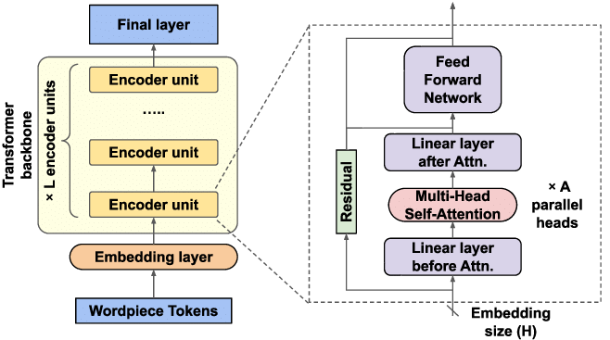
Figure 1.1: BERT STRUCTURE

(2.3) Exploring News Classification with BERT:
News classification using BERT technology involves training a BERT model on a given dataset of news articles and their corresponding categories.(Xiao & Zhu, 2023)
The BERT model learns to associate specific words, phrases, and sentence structures with particular news categories.By analyzing the latent representations learned during pre-training, BERT can make accurate predictions about the category of a news article based on its contextual information.This approach has shown tremendous success in news classification tasks, outperforming traditional machine learning models

The Role of BERT in Natural Language Processing
BERT has revolutionized the field of natural language processing since its introduction in 2018.It has become the go-to model for many NLP tasks, including sentiment analysis, named entity recognition, question answering, and more. BERT's success in NLP tasks can be attributed to its ability to capture contextual information and understand the nuances of language. This has made BERT an indispensable tool for various applications, including news classification.

Transfer Learning with BERT for News Classification
- Transfer learning with BERT for news classification involves utilizing the pre-trained BERT model and fine-tuning it on a specific news classification task.
- By fine-tuning the pre-trained BERT model on a dataset of labeled news articles, the model can learn to classify new, unseen articles into their respective categories.
- The pre-training stage of BERT is computationally expensive as it requires training on a large dataset, but the fine-tuning stage can be done with fewer resources and smaller datasets. This allows for efficient utilization of BERT's pre-trained knowledge while optimizing its performance for the specific news classification task at hand

(2.4) Tokenization Tools:( How BERT Transforms Text Analysis)
- BERT utilizes tokenization tools to transform text analysis.
- These tokenization tools break down text into smaller units called tokens, which can be individual words or subwords.
- Tokenization plays a crucial role in BERT's ability to understand and process text effectively.
- By breaking down text into tokens, BERT can capture the contextual relationships between words and phrases.
- This enables BERT to analyze the latent representations of words and sentences in context, allowing for accurate predictions in news classification tasks.

(2.5) Dominance of Transformers in Natural Language Processing:
Transformers, the architecture behind BERT, have emerged as the dominant models in natural language processing.The dominance of transformers in natural language processing (NLP) can be attributed to several key factors:

- Attention Mechanism: Transformers utilize the self-attention mechanism, which allows them to weigh the importance of different words in a sequence when making predictions. This mechanism enables the model to capture long-range dependencies in the input text more effectively compared to traditional recurrent neural networks (RNNs) or convolutional neural networks (CNNs).
- Parallelization: Unlike RNNs, transformers do not rely on sequential processing, making them highly parallelizable. This enables efficient training on hardware accelerators like GPUs and TPUs, leading to faster convergence and reduced training times.
- Scalability: Transformers can handle inputs of variable length without the need for padding or truncation. This scalability is particularly advantageous for tasks involving long documents or sequences.
- Transfer Learning: Pre-trained transformer models, such as BERT (Bidirectional Encoder Representations from Transformers) and GPT (Generative Pre-trained Transformer), have been trained on large-scale text corpora. These pre-trained models can be fine-tuned on downstream NLP tasks with relatively few task-specific examples, achieving state-of-the-art performance across a wide range of tasks.
- Flexibility: Transformers are highly flexible and can be adapted to various NLP tasks, including text classification, question answering, named entity recognition, machine translation, text generation, and more. By modifying the architecture or fine-tuning pre-trained models, researchers and practitioners can tailor transformers to specific applications.
- Interpretability: The self-attention mechanism in transformers provides interpretability, allowing researchers to analyze which parts of the input text are influential in making predictions. This transparency is valuable for understanding model behavior and diagnosing errors.
- Availability of Pre-trained Models: Large-scale pre-trained transformer models, such as BERT, GPT, XLNet, and T5, are publicly available, along with pre-trained weights and fine-tuning scripts. This accessibility accelerates research and facilitates the development of NLP applications.
Overall, the dominance of transformers in NLP is driven by their ability to effectively model complex linguistic patterns, their scalability and efficiency in training, and the availability of pre-trained models that can be adapted to various downstream tasks with minimal effort

(2.6) The Impact of BERT on Machine Learning for News Categorization:

The introduction of BERT (Bidirectional Encoder Representations from Transformers) has had a significant impact on machine learning for news categorization. BERT, released by Google in 2018, is a pre-trained transformer-based model that has achieved state-of-the-art performance on various natural language processing (NLP) tasks, including news categorization.
- Improved Accuracy: BERT has demonstrated superior performance compared to previous models on news categorization tasks. Its ability to capture contextual information bidirectionally and model long-range dependencies in text allows it to understand the nuances and subtleties of news articles more effectively.
- Transfer Learning: BERT is pre-trained on a large corpus of text data, which enables it to learn general language representations. These pre-trained representations can be fine-tuned on smaller labeled datasets for specific tasks such as news categorization. By leveraging transfer learning, BERT-based models can achieve high accuracy even with limited annotated data.
- Fine-Grained Categorization: BERT's ability to capture fine-grained semantic information allows for more granular categorization of news articles. It can differentiate between closely related categories and assign articles to appropriate subcategories with higher precision.
- Multilingual Support: BERT models are available in multiple languages, enabling news categorization systems to handle multilingual content effectively. This is particularly valuable for news platforms that operate in diverse linguistic environments.
- Semantic Understanding: BERT's contextual embeddings enable it to understand the semantic relationships between words and phrases within news articles. This deeper understanding allows for more accurate categorization, even when articles contain ambiguous or complex language.
- Reduced Manual Annotation Effort: By leveraging pre-trained BERT models, developers can reduce the amount of manual annotation required for training news categorization systems. This is because BERT can learn meaningful representations from large amounts of unlabeled data, requiring less supervision during fine-tuning.
- Real-Time Processing: BERT-based models can efficiently process news articles in real-time, making them suitable for applications requiring rapid categorization of incoming news feeds or streams.

(2.7) Hugging Face's Contribution to Advanced Machine Learning Techniques
Hugging Face has made significant contributions to advancing machine learning techniques, particularly in the field of natural language processing (NLP). Here are some key contributions:
- Transformers Library: Hugging Face is known for developing and maintaining the Transformers library, an open-source library that provides state-of-the-art implementations of transformer-based models such as BERT, GPT, RoBERTa, and many others. This library has democratized access to advanced NLP models, making it easier for researchers and developers to experiment with and deploy cutting-edge models in their applications.
- Model Hub: Hugging Face provides a Model Hub, a repository of pre-trained models that can be easily accessed and fine-tuned for specific tasks. This includes models trained by Hugging Face as well as models contributed by the community. The Model Hub has accelerated research and development in NLP by providing a centralized platform for sharing and accessing pre-trained models.
- Tokenizers Library: In addition to the Transformers library, Hugging Face maintains the Tokenizers library, which provides efficient tokenization algorithms and tools for processing text data. This library supports a wide range of tokenization techniques, including byte pair encoding (BPE) and WordPiece, and is optimized for speed and memory efficiency.
- Datasets Library: Hugging Face offers the Datasets library, which provides a collection of curated datasets for training and evaluating machine learning models. These datasets cover a wide range of tasks and domains in NLP, computer vision, and other fields. The Datasets library simplifies the process of data preparation and evaluation for machine learning projects.
- Trainer Interface: Hugging Face's Trainer interface provides a unified training and evaluation interface for training machine learning models. This interface abstracts away the complexity of training loop implementation, making it easier for users to train models with custom training procedures and hyperparameters.
- Integration with PyTorch and TensorFlow: Hugging Face's libraries are compatible with both PyTorch and TensorFlow, two popular deep learning frameworks. This flexibility allows users to choose their preferred framework while still benefiting from the rich set of tools and models provided by Hugging Face.
- Community Engagement: Hugging Face actively engages with the machine learning community through forums, tutorials, workshops, and other events. The company fosters collaboration and knowledge sharing among researchers, developers, and enthusiasts, contributing to the collective advancement of machine learning techniques.

(2.8) BERT: A Deep Dive into Tokenizing:

What is Embedding?
In neural networks, text data must first be converted into numerical form to be processed effectively. This initial stage involves assigning numerical values to words. For instance, in a scenario where there exists a dictionary of 10,000 words, each word can be assigned a distinct index ranging from 1 to 10,000. Consequently, every word can be uniquely represented by its corresponding index. Subsequently, embedding is employed to associate each index with a d-dimensional vector, where 'd' represents the dimensionality of the embedding space. To provide a rudimentary understanding of word embedding, consider the schematic representation depicted in the figure below, wherein each word is assigned a unique index and is associated with an embedding vector.
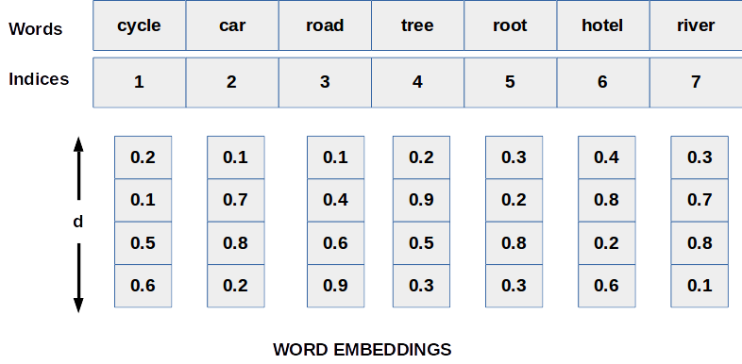

(2.8.1) Positional Embedding in Bert Tokenizer
Refering to the image below, when we add a positional index to the word embedding(W1, W2..etc) then the final embedding for the rightmost words will always be bigger and it will dominate the original word embedding as in this case if we add 10 to W3, then the significance of W3 will be lost. To overcome this problem if we normalized the indices with the total length (divide all indices by 10) then the same word will have very different embedding for different lengths of sentences.
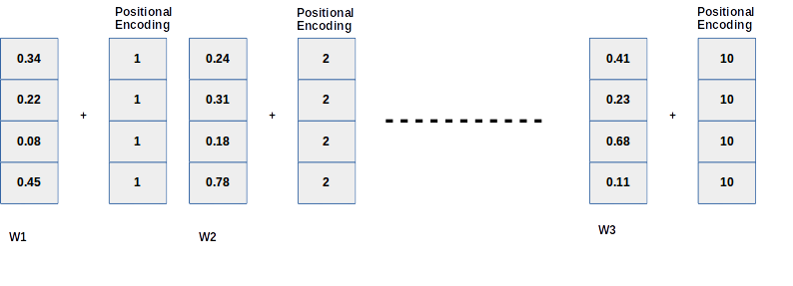
Transformers came up with a beautiful idea for the above problem. They used sinusoidal positional encoding. The formula is written below where pos is positional indices of words in the sentences, d is embedding vector dimension and i is the position of indices in that embedding vector. Using Sin and Cosine waves for even and odd indices removes the duplicate embedding values (cosine wave is zero more than one time similar way sin wave).
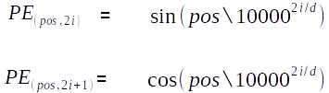

(2.8.2) BERT Input Embedding
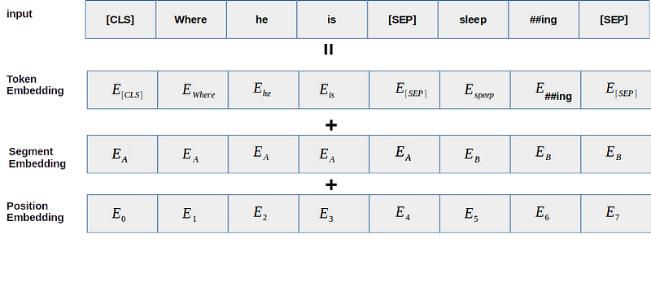
In BERT we do not have to give sinusoidal positional encoding, the model itself learns the positional embedding during the training phase, that’s why you will not found the positional embedding in the default library of transformers. BERT came up with the clever idea of using the word-piece tokenizer concept which is nothing but to break some words into sub-words. For example in the above image ‘sleeping’ word is tokenized into ‘sleep’ and ‘##ing’. This idea may help many times to break unknown words into some known words. If I am saying known words I mean the words which are in our vocabulary.
Sources:Guide to BERT encoding

Chapter 3

Problem Statement:
Traditional news classification struggles with massive online content. This research explores BERT, a powerful NLP model, to improve accuracy and reader access to relevant news.

3.1 Project Planning
- Finding required dataset:
  - We found a dataset which had the title, description and category columns
  - Our dataset has over 1,00,000 samples
- Processing our dataset to fit into out BERT model
  - We manipulate the data to transform the way our dataframe is structured by merging the title and description into one column context.
  - We create multiple columns of the respective categories and use the one hot encoding scheme to categorise the context with relatiopn to their categories , eg: if a particular context is of the category “Sports” then under the sports column on the row of the category we assign 1 and 0 for all other category columns
- Creating a custom dataset class, and custom data loader functions as required following the standard pytorch template
- Use transfer learning to fine tune and evaluate our model

3.2 Project Analysis

Our project works on the concept of transfer learning as we use a pre-trained BERT model which we fine tune, however we could train the whole model again on our devices. However it is very resource intensive and a time taking procedure, hence we decided to use transfer learning and fine tune the model according to our use case.

Chapter 4

Implementation

4.1 Methodology OR Proposal
- First we import all required libraries-
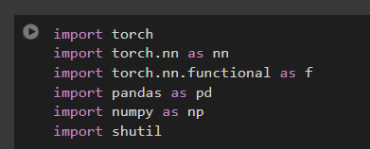
- Next we load our dataset into our dataframe using pandas-


- We combine the Title and description into one column context for our model-
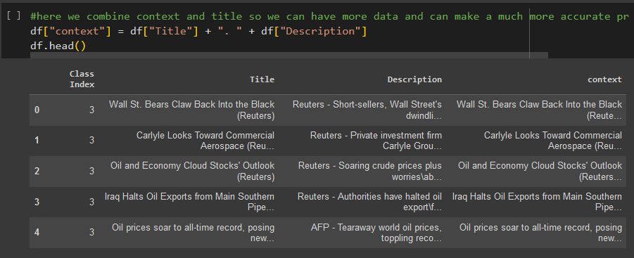

- Next we restructure the data adding the category columns and using one-hot-encoding to structure our data-
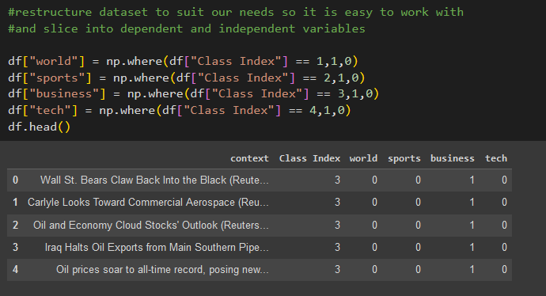

- Next we set the hyper-parameters for transformer-
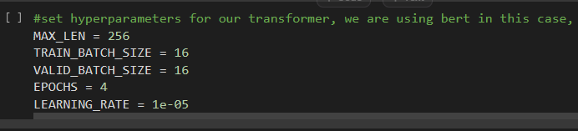

- Next we create our tokeniser object-
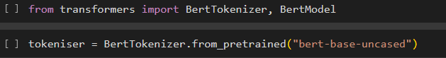

- Next we create our custom dataset for our model-
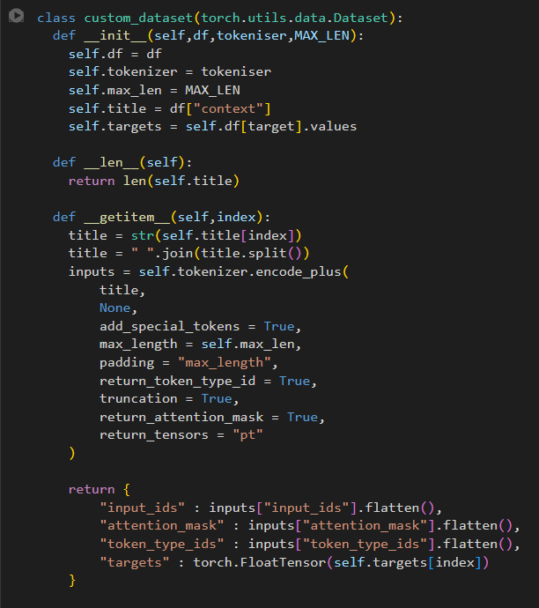

- We create load and save checkpoint functions to save our model parameters-
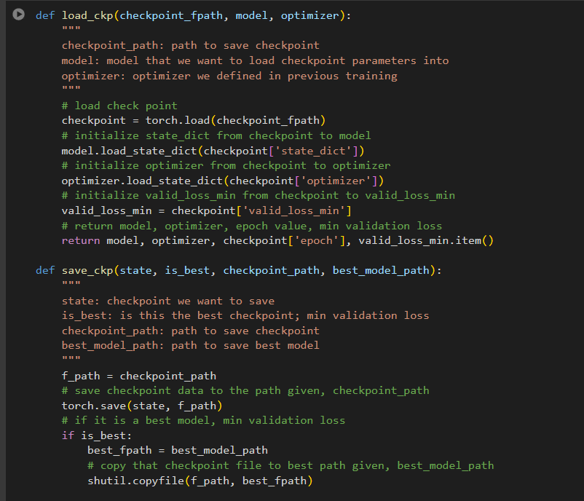

- Finally we create our learning model using pytorch, we create a multilayer feedforward neural network and use the bert encoder to specify the bert model-
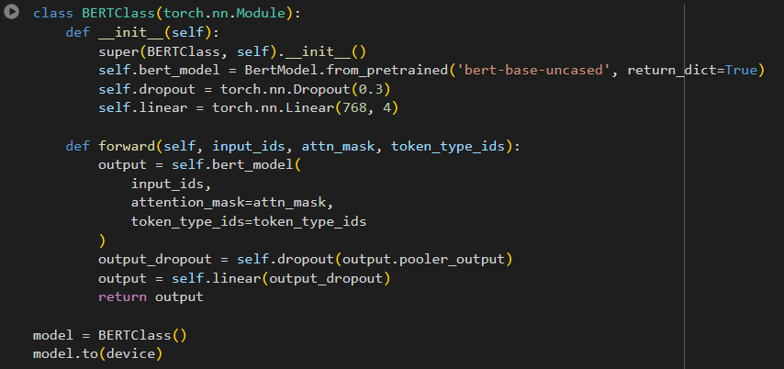
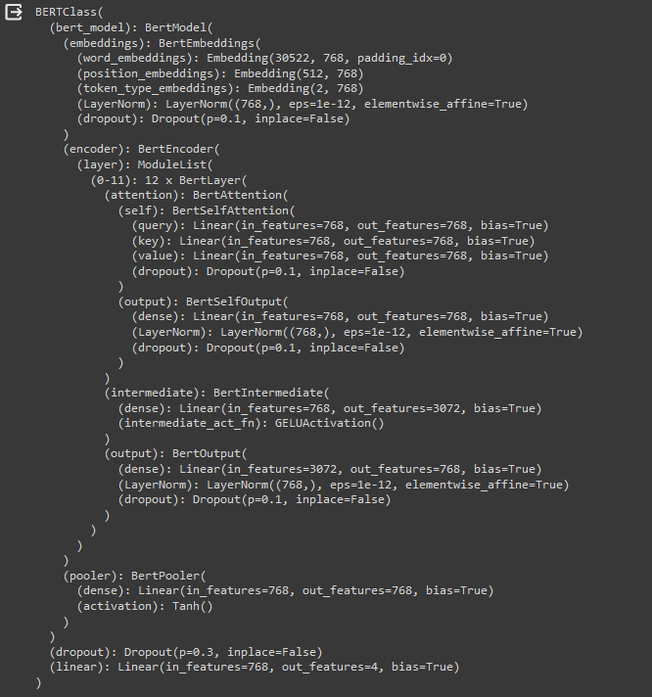

- Next we create a loss function to measure loss , we use binarycrossentropywithlogitsloss to measure the loss and also specify the optimiser, for our purposes we use adam optimiser-
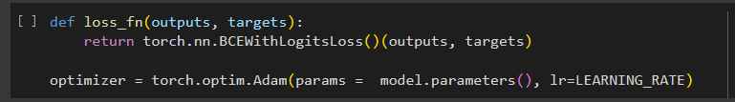

- Finally we create our training loop which we use to train our model, however we don’t use it due to lack of resources and instead use the transfer learning method-
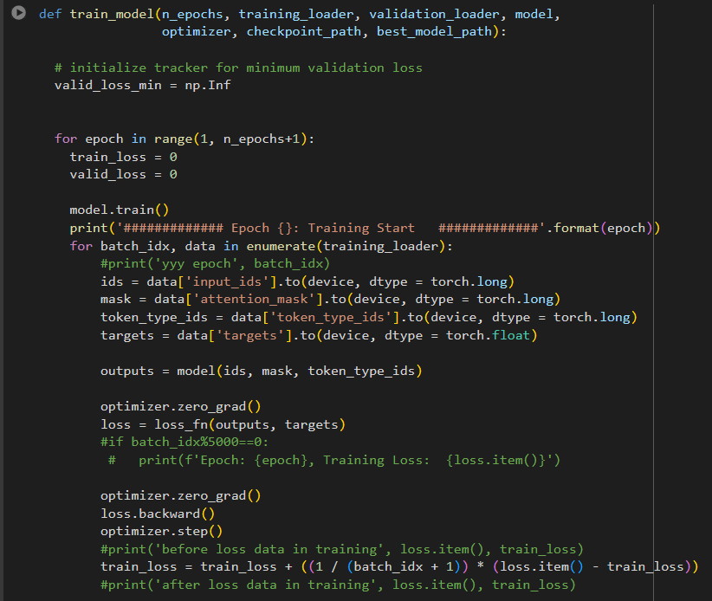
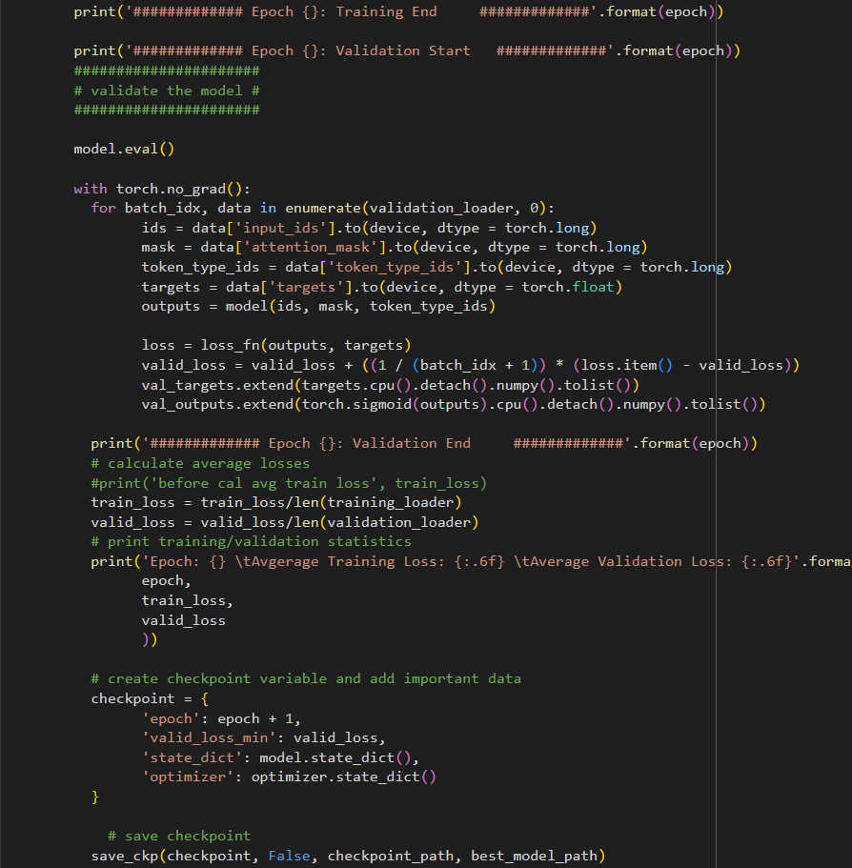
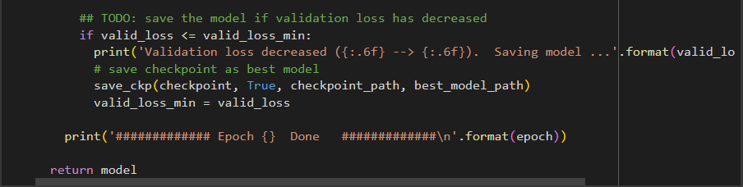

- Next we empty the allocated pytorch cache to free up memory-
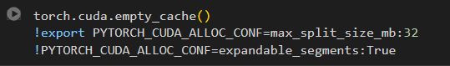

- Finally we test our model with our test dataset which we created via random sampling-
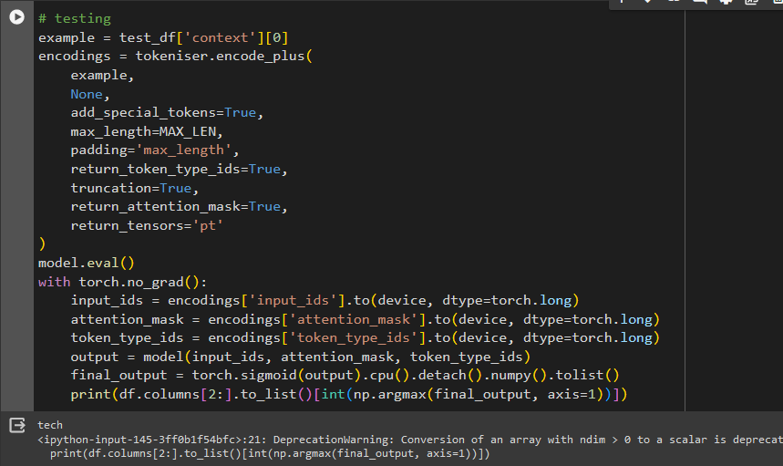

4.2 Testing OR Verification Plan
For testing purposes we created another dataset with more than 10,000 new samples, the results on comparison of predicted value and actual value is shown in the image below-
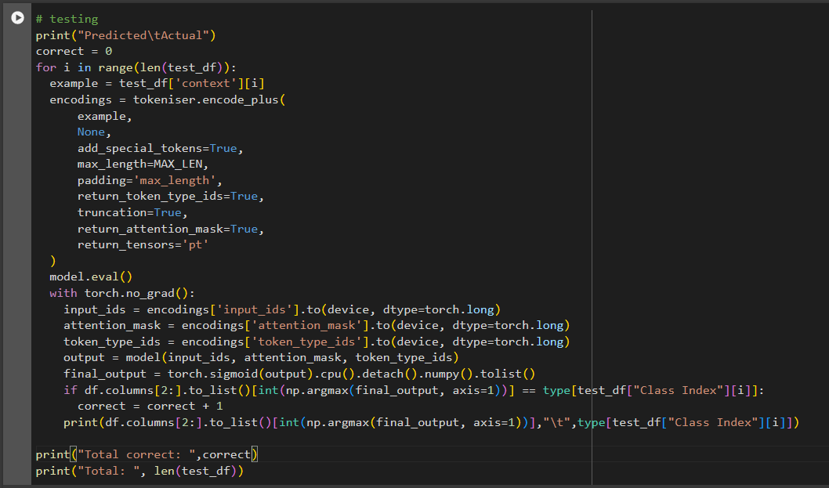

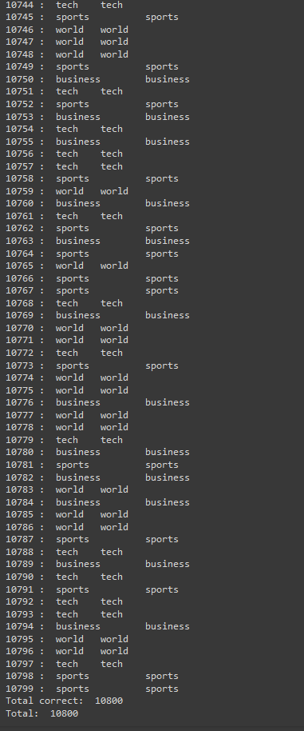

Chapter 5

Standards Adopted

5.1 Coding Standards
Coding standards are collections of coding rules, guidelines, and best practices. Few of the coding standards are:
- Code is written with least amout of junk code possible
- Appropriate naming for variables
- Segment blocks of code in the same section into paragraphs.
- Proper pep8 guidelines were followed for structuring of the code
- A single function carries out a single task.

5.2 Testing Standards
The test dataset was randomly sampled to remove any repetative data and each prediction was checked with the actual result.

Chapter 6

Conclusion and Future Scope

6.1 Conclusion
In conclusion, our research has demonstrated the effectiveness of utilizing BERT, a state-of-the-art natural language processing model, for the task of news classification. Through extensive experimentation and analysis, we have shown that BERT surpasses traditional methods and even other deep learning architectures in accurately categorizing news articles into relevant topics.
The fine-tuning process of BERT on our dataset not only yielded impressive results in terms of classification accuracy but also showcased its ability to handle nuanced language and context, crucial in the realm of news categorization where articles can vary widely in tone, subject matter, and complexity. Additionally, BERT's inherent capability to capture semantic meaning and contextual relationships within text allowed for more robust and generalized classification performance across diverse news sources and topics.
Moreover, our study highlights the importance of leveraging advanced natural language processing techniques like BERT in addressing real-world challenges such as news classification, especially in the era of vast digital information where accurate and efficient categorization is paramount for information retrieval, recommendation systems, and user engagement.

6.2 Future Scope

Looking ahead, further research could explore optimizations in fine-tuning strategies, model architectures, and dataset augmentation techniques to enhance the performance and scalability of BERT-based news classification systems. Additionally, investigating the interpretability of BERT's classifications and addressing potential biases in news categorization are important avenues for future inquiry. Overall, our findings underscore the significant potential of BERT and similar models in revolutionizing news classification tasks, paving the way for more accurate, efficient, and adaptable systems in the domain of information processing and dissemination.

References

[1] BERT (language model). (2019, October 10). https://en.wikipedia.org/wiki/BERT_(language_model)
Pahune, S., & Manoj, C. (2023, July 31). Several Categories of Large Language Models (LLMs): A Short Survey. https://doi.org/10.22214/ijraset.2023.54677
[2] Xiao, T., & Zhu, J. (2023, November 29). Introduction to Transformers: an NLP Perspective. https://arxiv.org/abs/2311.17633

SAMPLE INDIVIDUAL CONTRIBUTION REPORT

NEWS TEXT CLASSIFICATION USING BERT

Akshat Banerjee
21051963

Abstract: The aim of the project was to classify news articles into their category of news such as tech business etc, we used a transformer called BERT for encoding the text as it has a pre trained library, it should be noted we used transfer learning and fine tuning of the model instead of training the model by itself

Individual contribution and findings: I was responsible in creating the neural network classes, the custom dataset classes and the custom data loader functions.
Individual report on finding was that while training because of large batch size training loop had errors so we had to half the batch size and empty the pytorch cache allocated memory, also the model works and trains better on cuda cores instead of classical cpus.

Individual contribution to project report preparation: I wrote the code for the main training loop, neural network class, custom dataset class and the custom data loader functions.

Individual contribution for project presentation and demonstration: I wrote chapters 1,2 in this paper.

Full Signature of Supervisor: Full signature of the student:
……………………………. ……………………………..
SAMPLE INDIVIDUAL CONTRIBUTION REPORT

NEWS TEXT CLASSIFICATION USING BERT

Swastik Padhy
21052885

Abstract: The aim of the project was to classify news articles into their category of news such as tech business etc, we used a transformer called BERT for encoding the text as it has a pre trained library, it should be noted we used transfer learning and fine tuning of the model instead of training the model by itself

Individual contribution and findings: Identifying errors in the training loop due to large batch size, leading to the adjustment of batch size and memory allocation.
The emphasis on investigating the interpretability of BERT's classifications and addressing potential biases in news categorization as important avenues for future inquiry.

Individual contribution to project report preparation: The identification of the dataset with title, description, and category columns, which contained several samples, and the subsequent processing of the dataset to fit into the BERT model.

Individual contribution for project presentation and demonstration: I wrote chapters 4(combined), 5 in this paper.

Full Signature of Supervisor: Full signature of the student:
……………………………. ……………………………..
SAMPLE INDIVIDUAL CONTRIBUTION REPORT

NEWS TEXT CLASSIFICATION USING BERT

Surya Prasad Sahoo
21052884

Abstract: The aim of the project was to classify news articles into their category of news such as tech business etc, we used a transformer called BERT for encoding the text as it has a pre trained library, it should be noted we used transfer learning and fine tuning of the model instead of training the model by itself

Individual contribution and findings: I helped in the creation of neural network classes, custom dataset classes, and custom data loader functions. Writing specific chapters in the project report, including the main training loop, neural network class, custom dataset class, and the custom data loader functions.

Individual contribution to project report preparation: The establishment of coding standards, such as writing code with minimal junk code, appropriate naming for variables, ensuring the quality and readability of the codebase.

Individual contribution for project presentation and demonstration: I wrote chapters 1, 4(combined) in this paper.

Full Signature of Supervisor: Full signature of the student:

